AI-Augmented Backend Development Project:

TITLE: AI WEATHER WISE API

Project Description

In a Single Paragraph
AI – Weather wise API is an AI-Augmented backend Web Application developed using the (MongoDB, Express.js, Node.js) integrated with Artificial Intelligence capabilities such as Large Language Models (LLMs), Semantic Search, Vector Search, and Intelligent Recommendations. The system enables users to interact with data through natural language, receive AI-generated insights, perform semantic searches, upload and analyze documents, and automate decision-making processes. By combining traditional backend development with modern AI technologies, the platform delivers an intelligent, scalable, and user-friendly experience that improves productivity, accessibility, and operational efficiency.

Scenario
Weather conditions can change quickly and affect daily activities such as travel, agriculture, outdoor events, transportation, and business operations. Users often depend on traditional weather applications or manually check information from different sources to understand temperature, rainfall, humidity, wind speed, and forecasts. These systems may provide large amounts of raw weather data but do not always give personalized or easy-to-understand guidance. Users may also find it difficult to compare weather conditions for different locations and make timely decisions based on changing weather patterns.
Artificial Intelligence can improve this process by analysing weather data and providing intelligent, user-friendly insights. AI Weather Wise API collects weather information through APIs and processes it using AI techniques to generate meaningful weather summaries, answer natural-language weather questions, identify patterns, and provide personalized weather recommendations. Instead of requiring users to interpret complex weather data manually, the system can convert the information into simple and useful responses based on the user's location and requirements.
The proposed system can benefit students, travellers, farmers, event organizers, businesses, and general users who need accessible weather information. By combining Node.js, Express.js, MongoDB, weather APIs, and AI services, AI Weather Wise provides a centralized platform for accessing weather information, analysing weather conditions, and generating intelligent insights. This helps users understand changing weather conditions more easily and supports better planning and preparation.

- Describe the Proposed Solution
Explain how your < Project Name > addresses the identified problem using AI capabilities such as:
  - AI Chatbot
  - Content Generation
  - Question Answering
  - Semantic Search
  - Vector Search
  - Intelligent Recommendations
  - Document Analysis
  - AI-powered Insights

Structure:

Paragraph 1 – Problem:
Weather conditions can change frequently and affect daily activities such as travel, agriculture, outdoor events, transportation, and business operations. Users often depend on different weather applications or manually check weather information from multiple sources. Traditional systems mainly provide raw weather data such as temperature, rainfall, humidity, and wind speed, which can be difficult for users to understand and compare. This makes it challenging to get clear, personalized, and timely weather information for a specific location.

Paragraph 2 – AI Solution:
AI Weather Wise API solves this problem by combining weather APIs with Artificial Intelligence to analyse and understand weather data. The system provides an AI-powered weather assistant that can answer natural-language weather questions, generate simple weather summaries, analyse weather conditions, and provide intelligent weather recommendations. AI techniques such as natural language processing, intelligent insights, semantic search, and weather data analysis help convert complex weather information into useful and easy-to-understand responses.

Paragraph 3 – Impact:
AI Weather Wise API can benefit students, travellers, farmers, event organizers, businesses, and general users who need reliable and accessible weather information. The application reduces the need to manually analyse weather data and provides information in a simple and personalized way. It helps users understand current and forecasted weather conditions, plan activities more effectively, and prepare for changing weather conditions. The system also provides a centralized and scalable platform for accessing and analysing weather information.

System Requirements:
To ensure smooth development, deployment, and usage of the < Project Name > AI-Augmented Backend Application, certain system prerequisites must be met.

1. Software Requirements

Operating System
- Windows 10/11
- macOS
- Linux

Node.js (v18 or above)
Provides a runtime environment for frontend and backend development.

npm (v9 or above)
Package manager used for dependency installation.

Express.js
Backend framework used for API development.

MongoDB Community Server / MongoDB Atlas
NoSQL database used to store:
- User Information
- Chat History
- Documents
- Embeddings
- AI Interactions
- Application Data

MongoDB Atlas Search
Provides full-text search functionality.

MongoDB Atlas Vector Search
Enables semantic search using vector embeddings.

AI Service Provider
- OpenAI API
- Gemini API
- Claude API
- Azure OpenAI (Optional) …etc

Lang Chain / AI SDK
Used for orchestration of AI workflows.

Browser
- Google Chrome
- Mozilla Firefox

Postman
API Testing

Visual Studio Code
Development Environment

Git & GitHub
Version Control

2. Hardware Requirements

Processor
Intel Core i5 (8th Gen+) / AMD Ryzen 5+

RAM
Minimum 8 GB
Recommended 16 GB

Storage
Minimum 5 GB Free Space

Internet Connection
Required for AI API communication

Display
1366 × 768 or above

Project Architecture

Technical Architecture

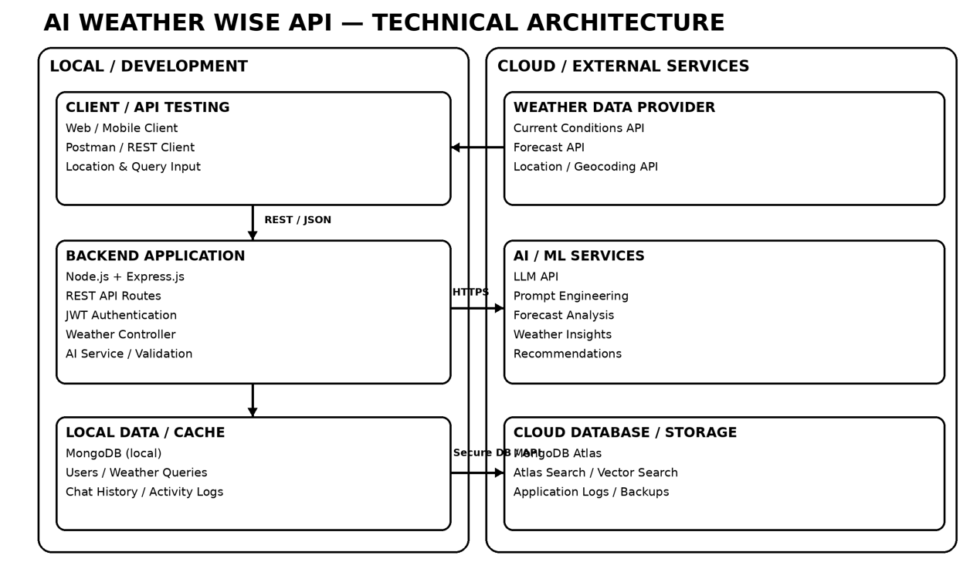

Backend Layer
- Node.js
- Express.js
- JWT Authentication
- REST APIs

Database Layer
- MongoDB
- Atlas Search
- Atlas Vector Search

AI Layer
- LLM APIs
- Embedding Models
- RAG Pipeline
- Prompt Engineering

Storage Layer
- MongoDB Collections
- File Upload Storage

Security Layer
- JWT Authentication
- Protected Routes
- Input Validation
- Role-Based Access Control

- ER Diagram

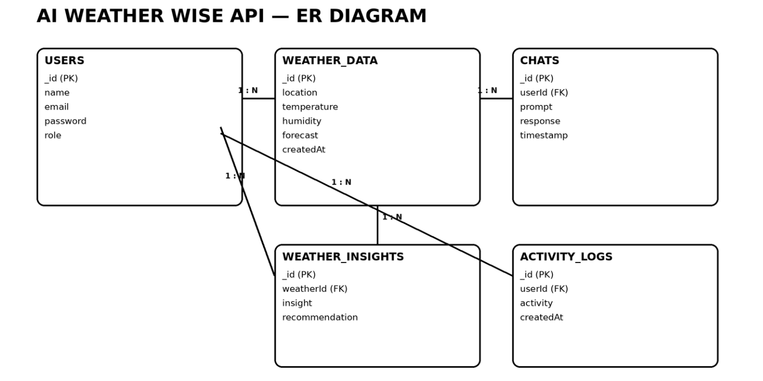

Collections

Users
- _id
- name
- email
- password
- role

Documents
- _id
- title
- content
- uploadedBy
- createdAt

Embeddings
- _id
- documentId
- vectorData

Chats
- _id
- userId
- prompt
- response
- timestamp

Activity Logs
- _id
- userId
- activity
- createdAt

ER Diagram Explanation
Users can upload documents and interact with AI features. Uploaded documents are processed into vector embeddings and stored in MongoDB. Chat interactions and AI responses are logged for future reference and analytics. Activity logs maintain user actions across the system.

Features

Core Backend Features
- User Registration
- User Login
- JWT Authentication
- Protected Routes
- Middleware
- CRUD API
- File Upload
- Role-Based Access Control

AI Features
- AI Chat Assistant
- Semantic Search
- Vector Search
- Document Question Answering
- Text Summarization
- Content Generator
- RAG (Retrieval Augmented Generation)
- Intelligent Insights
- Natural Language Queries

Roles and Responsibilities

Admin
- Manage Users
- Manage Documents
- Monitor AI Usage
- View Analytics
- Configure System

User
- Register/Login
- Upload Documents
- Ask Questions
- Search Content
- View AI Recommendations
- Manage Personal Data

User Flow
- User Registration
- User Login
- JWT Authentication
- Dashboard Access
- Upload Documents
- Generate Embeddings
- Store Vectors in MongoDB
- User Query Submission
- Semantic Search Execution
- AI Response Generation
- Display Results
- Store Chat History

MVC Pattern
The backend follows the MVC (Model-View-Controller) architecture.

Model Layer
Responsible for:
- User Schema
- Chat Schema
- Document Schema
- Embedding Schema
- Activity Schema
Implemented using Mongoose.

Controller Layer
Responsible for:
- Authentication Logic
- AI API Integration
- Document Processing
- Embedding Generation
- Search Operations
- CRUD Operations

View Layer (Routes)
Defines REST API endpoints:

Authentication Routes
- Register
- Login
- Logout

AI Routes
- Chat
- Summarization
- Semantic Search

Document Routes
- Upload
- View
- Delete

User Routes
- Profile
- Dashboard

Advantages of MVC
- Separation of Concerns
- Better Maintainability
- Easy Scalability
- Reusable Components
- Team Collaboration
- Easier Testing

Project Setup and Configuration

Project Structure
Create Project Folder
Inside Project Folder:

Server Folder
Backend Application

Server Setup
mkdir server

cd server

npm init -y
Create:
server.js

models/
controllers/
routes/
middlewares/
config/
services/
utils/


Install Backend Packages
npm install express mongoose cors dotenv bcryptjs jsonwebtoken

npm install OpenAI

npm install Multer

npm install nodemon --save-dev


Backend Development
Include:
- Authentication APIs
- JWT Implementation
- AI Service Integration
- Vector Search APIs
- CRUD APIs
- Document Upload APIs
- Chat APIs
Note:
Proper explanation must be provided for every AI API consumed, including:
- AI API Consumption

● Purpose:
The Weather-Wise API uses an external Weather API to retrieve real-time and forecast weather information such as temperature, humidity, wind speed, rainfall, weather conditions, and location-based forecasts. An AI service is used to analyze this weather data and generate simple summaries, answer natural-language questions, and provide intelligent weather recommendations.
● Request Structure:
The backend sends a request to the Weather API using parameters such as API key, city or location, latitude, longitude, and required forecast information. The AI service receives the collected weather data along with the user's query or prompt. Example request data includes location, current weather values, forecast data, and the user's question.
● Response Structure:
The Weather API returns structured weather information such as location, temperature, humidity, wind speed, rainfall, weather condition, and forecast details. The AI service processes this information and returns a natural-language response containing a weather summary, answer, or recommendation that can be displayed to the user through the Weather Wise application.
● Cost Considerations:
The cost depends on the weather API provider and AI service provider used by the application. Free or limited API plans can be used during development and testing, while paid plans may be required for higher request volumes. API usage should be monitored to control unnecessary requests and reduce operational costs.
● Security Practices:
API keys and sensitive credentials must be stored securely in environment variables such as .env files and should never be exposed in frontend code or public repositories. The backend should validate user inputs, use HTTPS for API communication, implement authentication and authorization where required, apply rate limiting, and avoid storing sensitive API credentials in logs or database records.

Database Development
Include:
- MongoDB Collections
- Relationships
- Atlas Search Index
- Vector Search Index
- Sample Documents
Provide screenshots and explanation.

Project Execution

Step 1: Backend
cd server

npm install


Step 2: Configure Environment Variables
Create .env
PORT=8000

MONGO_URI=mongodb://localhost:27017/ai_augmented_db

JWT_SECRET=your_secret_key

OPENAI_API_KEY=your_api_key


Step 3: Run Backend
nodemon server.js
Backend URL:
http://localhost:8000


Output with Explanation

● API Testing: Screenshots of Postman API testing showing requests and responses for weather-related endpoints such as current weather, forecast, location search, and user authentication.

● LLM Integration: Screenshot showing the integration of the Large Language Model (LLM) with the Weather-Wise backend. The LLM processes weather data and generates meaningful weather-related responses.

● AI Chat Interface: Screenshot of the AI Weather Assistant interface where users can enter natural-language questions such as “What is the weather today?” or “Will it rain tomorrow?” and receive AI-generated responses.

● Weather Data Upload: Screenshot showing the process of uploading or submitting weather-related data to the Weather-Wise system for processing, storage, and analysis.

● Search Results: Screenshot showing location-based weather search results, including temperature, humidity, wind speed, rainfall, weather condition, and forecast information.

● Recommendation Engine: Screenshot showing AI-generated weather recommendations based on current and forecasted conditions, such as travel suggestions, outdoor activity guidance, rain alerts, and weather precautions.

Demo Video Link
https://drive.google.com/drive/folders/1BybUnYmvrnhCyKSXZp4-bL4gq3xGjREN?usp=sharing

Source Code Drive Linkhttps://drive.google.com/drive/folders/1soRaUNjfH0P9oygFRqPzix-N7RmqFoWF?usp=sharing

Mandatory Functionalities
- MVC Architecture
- JWT Authentication
- Semantic Search
- MongoDB Atlas Search
- MongoDB Atlas Vector Search
- Prompt Engineering
- AI API Integration
- Role-Based Access Control

